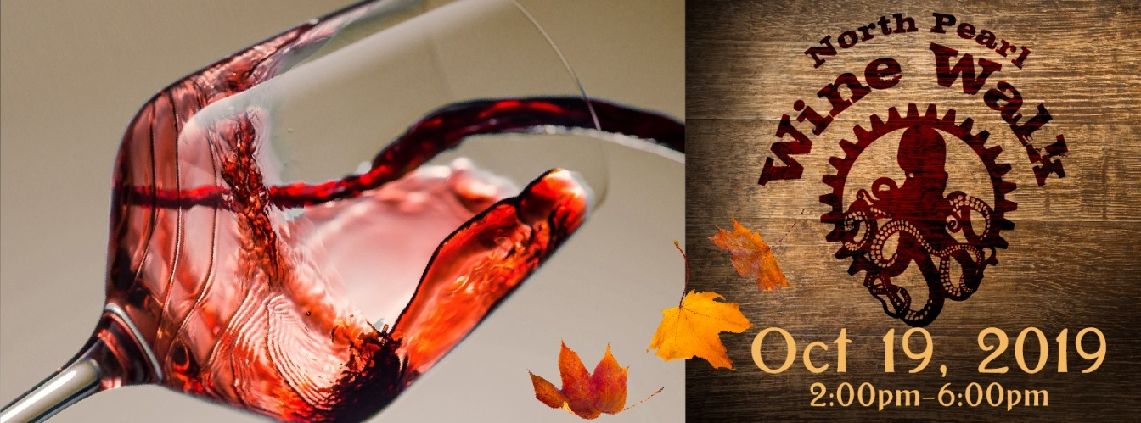
North Pearl Wine Walk 2019
October 19th, 2019
What it is: A collection of North Pearl businesses getting together and getting their customers drunk! Just kidding. We will be serving wine, though. Things to know below!
- Date: October 19th, 2019, Time: 2-6pm
- Participants: YOU – if you let us know NO LATER THAN August 10th, 2019
(to be included in permits and marketing materials)
- Expected Number of Walkers: 500
How it works: All participating locations will have a winery or a selection of red and white local wines at their facility, provided by the North Pearl Business District. Walkers will exchange a token for a 2oz measured pour. Tokens will be provided at the designated check in point for the event, along with a map of the venue representing all businesses and activities.
In celebration of Tacoma’s Art Month, we will be working with The Artist’s Collective to pair artists and artisans with your facility as well. These artists will be vetted and approved by each location before confirming placement; you need to enjoy the art in your space, too!
Door Prizes: To encourage customers to return to the district and continue exploring all North Pearl has to offer, each business will contribute a door prize to the event. Remember, these are wine walkers; the clientele is more high end than you’d see at a fair or farmer’s market. Keep that in mind when selecting your door prize. You will collect door prize tickets from walkers and will be responsible for selecting your winner. Please feel free to use the rest of the information you’ve collected for your marketing purposes!
Advertizing: The event will be ticketed and will be advertised on www.explorenorthpearl.com, social media pages, etc. and tickets will be available for purchase through Eventbrite (http://bit.ly/NP-WineWalk). Early Bird Tickets for the event will be $25 each and will include tokens, commemorative wine glass, map of participating locations and door prize tickets. Ticket sales will be limited to 500 walkers – this is more than we sold last year!
Why it’s awesome: The Wine Walk gives all businesses an opportunity to mingle and connect with a local customer base that may otherwise not patronize their establishment. As the wine must be consumed within the participating business, this gives patrons an opportunity to browse your wares and connect with you and your lovely staff. Make impressions, make some friends, and you will also be make some sales.
Finer points: All businesses participating must let Chantine McBain (see below) no later than August 10th, 2019. We are creating a map, a stamp passport, and promotional materials that will list your business, so we do need confirmed participation ASAP in order to finish up those items. Things to consider before deciding to participate:
- Buy-In: Each business will be charged $150 for non-business district members, $100 for district members in good standing (IE dues paid). This buy-in fee will cover the cost of the permits, insurance, and marketing for the event. Note our social media regularly has over 1,000 views.
- Winery Space: Each business will be responsible for providing a table/designated space for the winery to set up. Due to permitting, you will need to determine the designated area for pouring ahead of time. This area needs to be monitored during the event.
- Artist Space: Each business will also need to determine a location (wall space, area, etc) for a local artist to set up. Chantine McBain will be working with each business to determine the best artist and/or medium to be placed at the facility, but if you have a request for a specific artist or type of art, please reach out.
- Door Prize: Each business MUST contribute a door prize (also known as a raffle) to the event. This will be housed at your location and you will be responsible for selecting the winner – however, you must let Chantine know what that door prize is so it can be added to the printed map and marketed appropriately.
- Wine Rules: All wine must be consumed within your business. No one can leave your establishment with wine in their glass; it is up to you to monitor that and (politely) remind everyone that wine cannot leave the business. The walkers are free to wander within the bounds of your shop, but cannot leave the facility with wine in their glass.
- Over 21: Wine pours should only be given to ticketed walkers who are identifiable by a wristband. The wristband indicates that their IDs have been checked and they are legal to drink. If your shop is still open to the public during the event, please be vigilant about only serving those with wristbands and tokens to exchange for a pour.
- Hours of Operation: The event is from 2-6pm; each participating business needs to remain open during this time. No exceptions.
- Be Awesome: This event is awesome; each participating business needs to like being and/or be willing to be awesome. Easy enough, because you are awesome!
More details are forthcoming; if you’re interested in the event, let us know and we will get you on the list and start marketing your awesome business through our social media platforms. We’re also looking for any ideas or assistance you’d like to throw out – the more participation and creative energy, the better!
Cheers,

